Learning at Home Stage 3

We hope that your Learning from Home has been smooth for most since the Easter break and that everyone is working hard at trying to navigate their learning activities. It has been really nice to connect with so many of you in either face-to-face, via Zoom, via email and by chatting to you in Google Classroom. We all want you to know how proud we are of the children and the effort they have been putting in to their work. We are loving seeing their work that has been either added to Google Classroom or sent in by email by their amazing parents.
We want to take the opportunity to remind everyone in Stage 3 that the timetables the teachers have set up for you and your classes are a suggestion of how your day of learning can look. All timetables are flexible and can be changed based on family commitments. Please be kind to yourselves when it comes to completing the work and families trying to also work from home. We understand the juggle of work and school life and if children can't get all the work done it is ok.
We really want to remind all of our Stage 3 students to make sure that they are marking their attendance in their Google Classroom even if they are working offline and to ensure that they are making contact with their teachers.
All of our Stage 3 teachers continue to prepare for the next phase of learning for their students as we move to a mix of onsite and offsite learning. This work will continue to be shared with the students in their Google Classroom and emailed out to parents by the class teachers.

As always, your classroom teacher is your first point of contact if you should have any questions or queries about anything.
​We are all looking forward to next week and the opportunity to see as we transition into the new phase together.

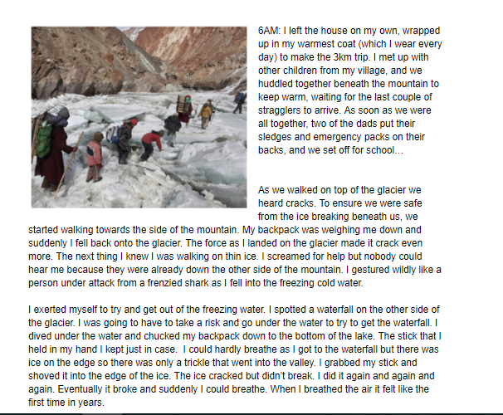
Written by: George Burt 4/5T

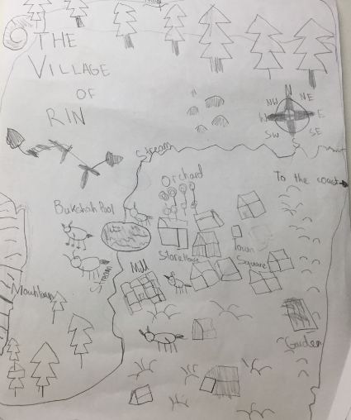
Map of Rin by Long Vuong in 4/5T

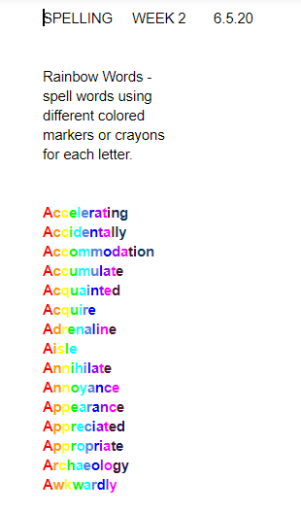
Spelling word by Auggie Escribano 4/5T

