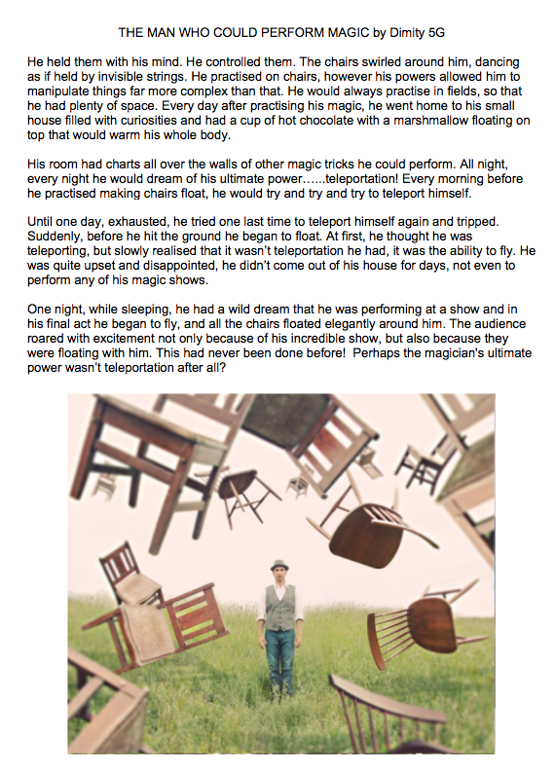
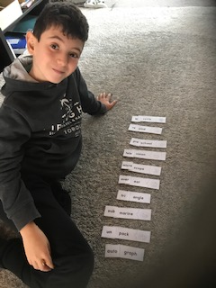

Alex K, 5G practising his Prefixes and Suffixes

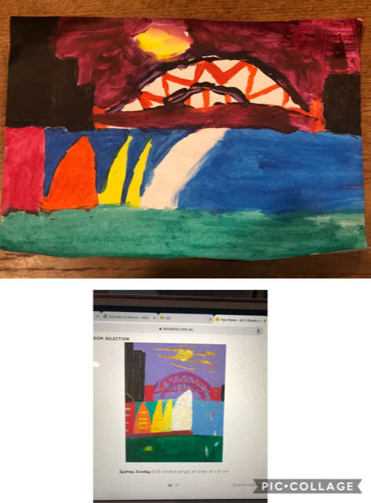
Heidi P, 5G - Interpretation of a Ken Done painting.
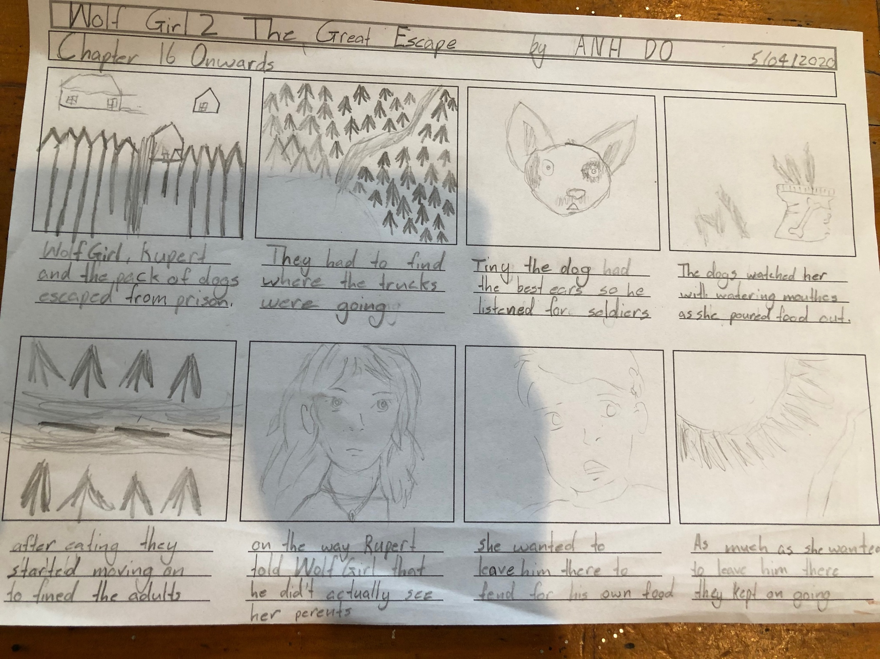

Storyboard activity completed by Tolley 5G

