

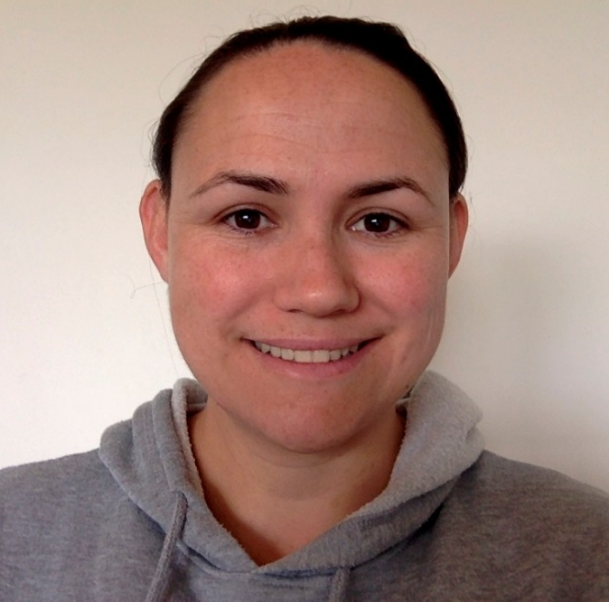

Hi, my name is Colleen Gay, I am a second-year university student studying a Bachelor of Education (Primary/Middle) at the University of South Australia. I minor in Visual Arts and Humanities and Social Science. I chose these two areas to specialise in because I enjoy being creative through visual art and have an interest in the humanities and social science areas.

I have chosen to be a teacher because during my schooling I had a number of teachers who went above and beyond to support me and my learning. These teachers have been positive role models and I want to do the same for my students once I am a qualified teacher. I have always supported family members and my community and pride myself on being a positive role model. I believe that all students deserve to have a safe learning environment with high expectations set early, allowing for every child and young person to achieve in their own learning journey.

This is my second placement and I will be here for a total of 20 days. I am looking forward to getting to know all students, carers, staff and the wider school community.

Please come and say hello to me while I am here, I can’t wait to meet you.

