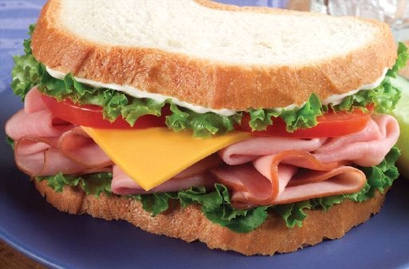 NATATS CANTEEN MENU 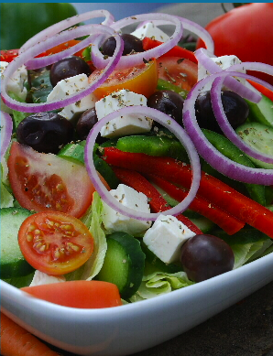
CRUNCH & SIP $1.80 Available Before 10am Bottle Water & your choice of one from Cool snacks

E= Everyday O= Occasional V= Vegetarian H= Halal

Tiger sandwiches  VH: Veg/jam/che spread E $1.50  H: Egg & lettuce or mayo E $3.00  H: Tuna& lettuce or mayo E $3.00  H: Roast chicken E $3.50  H: Chicken, let & mayo E $4.50  Leg ham & cheese E $4.00  VH: Salad E $3.50  Add ham or chicken E $4.50  Rice paper rolls  VH: Vegetarian  Carrot, cucumber, celery, capsicum  Carrot, cucumber, capsicum  H: Chicken or Tuna with  Carrot, cucumber  Or Cabbage, celery  $3.00 each  with your choice of  Soy, sweet chilli, sweet & sour sauce | Wrappas  VH: Salad E $4.50  H: Egg & salad E $5.00  H: Roast chicken E $4.00  H: Roast chick, let, mayo E $5.00  H: Roast chicken & salad E $5.00  Leg ham E $4.00  Leg ham, cheese, tomato E $4.50  Leg ham & salad E $5.00  Roast chicken Caesar  with bacon & cheese O $5.50  Bacon, lettuce, tomato O $4.50  H: SW- chilli tender, let, mayo $4.00  Salad Bar  VH: Salad cup E $2.50  VH: Rice salad E $4.00  VH: Salad boat or box E $5.00  H: Pasta salad E $4.00  Add chicken, tuna or ham $5.00  Chicken Caesar salad box O $5.50  H: Egg salad box E $5.50  Ham or chicken salad box E $5.50  H-soy wings & salad box E $5.50 | Subs  VH: Oven bake wedges O $4.50  With-lett, tom, corn, cheese  Beef or chicken E $4.50  With let, tom, corn, cheese  Meatball O $4.50  With tom, corn, cheese  Burger Bar  Cheese ( beef pattie T/S ) E $3.50  Meatball O $3.50  With cheese, bbq/tom sauce  H: Chicken breast let, mayo O $4.00  H: Char grilled chick breast E $5.00  With lettuce & mayo  H: chicken breast E $4.50  With lettuce & mayo & peri sauce  H: Hawaiian E $5.00  With chick breast, che, pineapple  H: Roast chicken & cheese E $4.50  V: Vegetable burger $4.00  Sauce sachet $0.50  Tom, bbq, sw. sour, soy, Mild s chilli | Home made (every day)  VH: Corn cob $1.00  H: Chicken kebab stick $3.00  VH: mac & cheese $4.00  V: Vegetarian lasagne $4.00  VH: Cheese & spinach shells $4.00  H: Chicken lasagne $4.00  H: Beef lasagne $4.00  H: Chicken spag bol $4.00  Beef spag bol $4.00  H: Curried chicken & rice $4.50  H: Butter chicken & rice $4.50  V: Cheese pizza $5.00  Occasional foods  VH: Oven bake wedges $3.00  VH: Oven bake spring rolls (4) $2.00  H: Light sausage roll $3.50  Light 2x Party pies $3.00  H: Premium breast nugget $0.80  H: cup noodles $3.00

