E= Everyday O= Occasional
NATATS CANTEEN MENU

CRUNCH & SIP $1.80 Available Before 10am Bottle Water & your choice of one from Cool snacks
Cool snacks

E: Piece fruit $1.00
E: Fruit kebab $1.00
E: Melon wedge $1.00
E: Mixed fruit bag $1.00
E: Frozen orange bag $1.00
E: Carrot bag $1.00 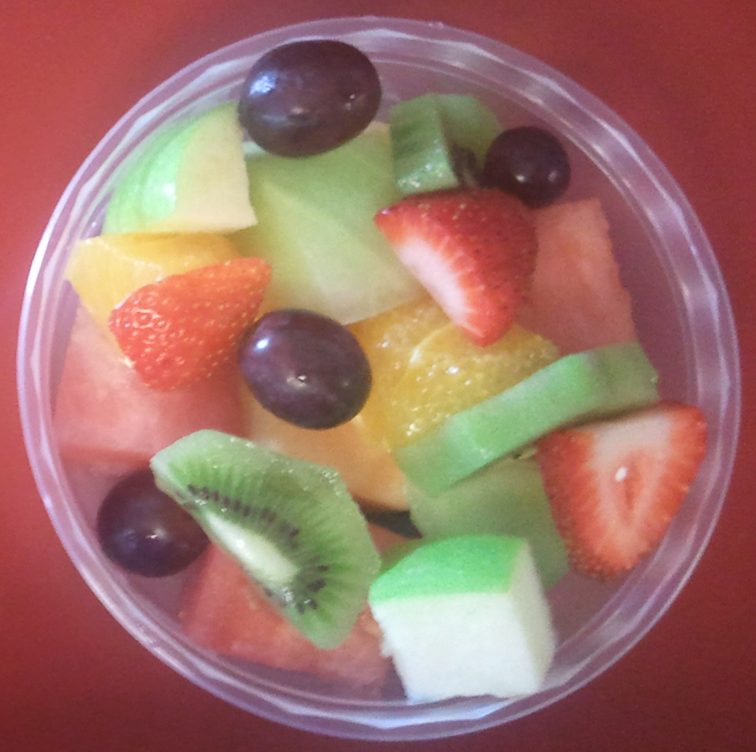

Snack attack

E: Mini muffin $0.20
E: Low fat custard cup $1.20
E: Low fat fruit & custard cup $1.50
E: Low fat yoghurt pouch $2.00
E: Melon tub $2.00
E; Frozen grape bag $2.00
E: Fruit salad $3.00
E: Egg bag $1.00
O:2x celery boat with filling $1.50
O: Mammes $1.00

V= Vegetarian
Drinks

E: Water 600ml $2.00
E: Poppers 100% $1.60
E: Berri pop top juice $2.00
E: Juice bomb $2.50
E: Chill 100% juice $2.50
E: Plain milk $1.50
E: with sippah straw $2.00
E: Big M chocolate $2.50
E: Big M strawberry $2.50
E: Up & Go chocolate $3.00

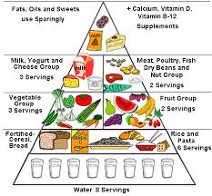

Our school canteen
complies with the NSW
Healthy school canteen
food & drink benchmarks

H- Halal

Lunch pack deals are available
From your canteen also from
Munch monitor on line ordering

www.munchmonitor.com

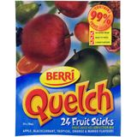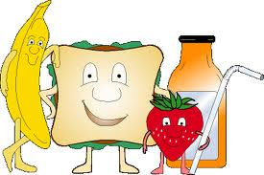

Ice Blocks

E TNT Snaps $1.00
E: Quelch stick $0.70
E: 100% juice cup (apl) $1.00
E: 100% juice cup (abc) $1.00
E: Frozen 100% popper $1.60
E: TNT Mony $1.00

