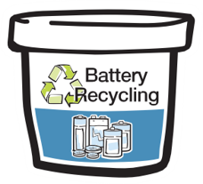
Sustainability
Collection of Household Batteries for the School Battery Collection Program

Aspiri Primary School is participating in the City of Armadale Battery Recycling Program. This collection program is an important part of managing our waste and helping to reduce the negative impacts of our waste on the environment.

To participate collect single-use batteries from your home when they have stopped working. Simply reuse a plastic container like an ice-cream container or even a small box or reusable bag to bring them to school in.

Bring these to school and empty them into the battery recycling collection bucket found in the school Library.

Batteries collected in this program are recycled into new batteries diverting them from landfill. Batteries accepted through this program include:

