**2020 Host Families Needed**

In 2020 Palmerston will be hosting a volunteer Japanese Language Teacher’s Assistant (JTA), Miss Asahi Sekimoto from Kagoshima University in southern Japan. During her stay she will be assisting in Japanese language classes 3-6, while also hoping to also improve her English skills. (Please see the reverse page for more information on her.)

JTAs are home stayed within the school community and pay a contribution towards food and board of $180 a week to their host families. Assistants need their own rooms but can share the family bathroom.

This program is widely used in ACT schools (there have been over 90 assistants since 2004) and is of great benefit to both the Japanese program and to the families who become involved. We find that families really enjoy this experience as it allows them to expand their knowledge and understanding of Japan and its’ people as well as contribute to the corporate life of the school. This is an ideal way to encourage your children to engage with Japanese language and culture and make lifelong friends.

We are therefore seeking expressions of interest from families who would be willing to host our JTA for a period of 6-10 weeks (eight weeks in ideal) in Terms 3 – 4 of 2020.

If you are unable to host for a longer term but are interested in offering weekend stays, emergency back up or the occasional social activity please also return the form below.

If you are able to assist us or would like more information please either return the slip below to the front office or email me at [Kristina.collins@ed.act.edu.au](mailto:Kristina.collins@ed.act.edu.au) and I’ll get in touch. This program relies heavily on the support and hospitality of the school community and your generosity is much appreciated.

Kristina Collins

Executive Teacher & Japanese Language Teacher

Name____________________ Phone________________________ Email:___________________

Children at school__________________________ Class_________

1. We would be interested in hosting a JTA

for a period of 6 8 10 weeks

in Term 2 3 4

3. We would like to offer other support by…….

4. We would like more information on this program.

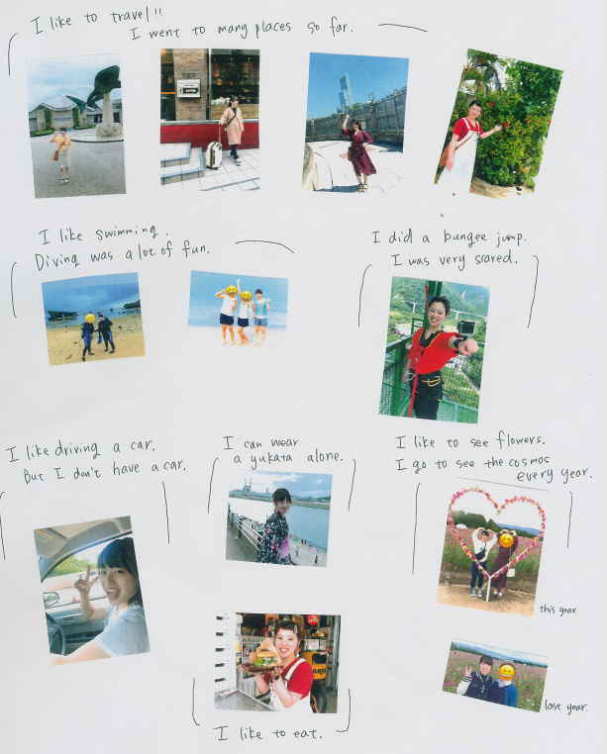

Asahi is 20 years old and is currently a student of the Faculty of Education. She plans to teach Maths in Junior High School eventually. She likes swimming and Volleyball. In College she tried drums, bungee jumping and boxing!

She doesn’t like birds very much. She dislikes leeks and mushrooms, pickles and dried fruit but likes cheese, meat and dessert.