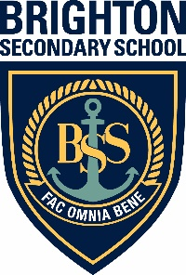

Brighton Special Interest Music
Information Evening for Years 6 & 7

Everything you need to know about auditioning for the
Brighton’s Special Interest Music Program

Tuesday 24 March 2020, 6.30 to 7.30pm
Brighton Secondary School Concert Hall

For all enquiries please call Pam Parsons 8375 8215
or email: pamela.parsons939@schools.sa.edu.au

