BH OOSH VACATION CARE

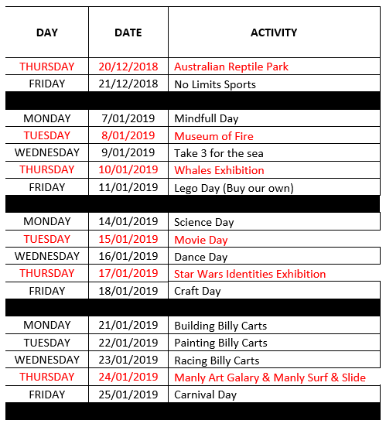
Best Regards
Chelsea O’Sullivan
P: 9975 2859
W: www.bhoosh.com.au

