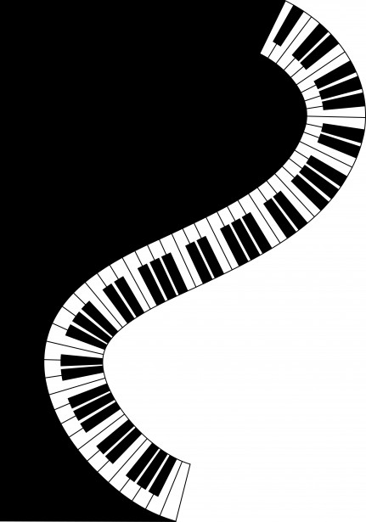

PIANO & KEYBOARD LESSONS

My name is Lee Adams and music is my passion! I am a registered Performing Arts Teacher, with 20 years plus experience in DECD schools and a Private Piano and Keyboard Teacher for some 30 years, looking for more students!! A vacancy has become available at St Leonards Primary and I would be happy to offer my services. If you child would like to participate in lessons please complete the form below and return to the front desk and I will contact you to arrange times and details of lessons. Lessons are 30 minutes each week, possibly on a rotating basis. The cost is $27:00 for individual lessons and $17:00 for group lessons (2 student maximum). If you have any further queries please me on 0417 263041.

Please return to front office

Parent’s Name: _________________________
Child’s Name: __________________________
Mobile Phone: __________________________
Email Address: __________________________
Room: _______________
Individual Lesson: __________
Group Lesson: _________
NB Generally, missed lessons are not refunded

Students should have access to a keyboard or piano for regular practise!!

