PAYMENTS

Payments can be made online or by cash. The preferred payment method is online.

Cash Payments: Please place money in an envelope clearly marked with your child’s full name, class and what payment is for.

Online Payments:
1. Go to the school website: https://pendlehill-p.schools.nsw.gov.au/

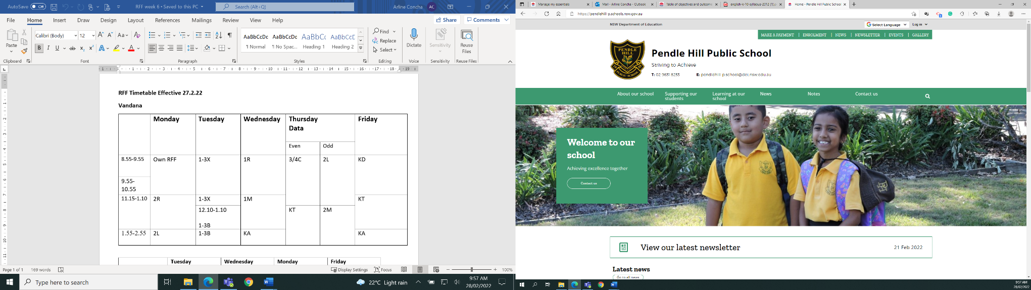
2. Click on MAKE PAYMENT

This will open a new window

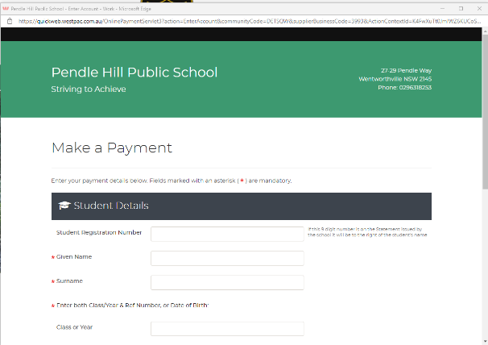

3. Fill in all details marked with a red Asterix *

4. Complete payment details. Payment can be made by
Visa or Mastercard.

PAYMENTS

Payments can be made online or by cash. The preferred payment method is online.

Cash Payments: Please place money in an envelope clearly marked with your child’s full name, class and what payment is for.

Online Payments:
1. Go to the school website: https://pendlehill-p.schools.nsw.gov.au/

2. Click on MAKE PAYMENT

This will open a new window

3. Fill in all details marked with a red Asterix *

4. Complete payment details. Payment can be made by
Visa or Mastercard.

