# Pendle Hill 2005 Crest

# PENDLE HILL PUBLIC SCHOOL

**Pendle Way, Wentworthville 2145**

**Phone: 9631 8253 Fax: 9896 3082**

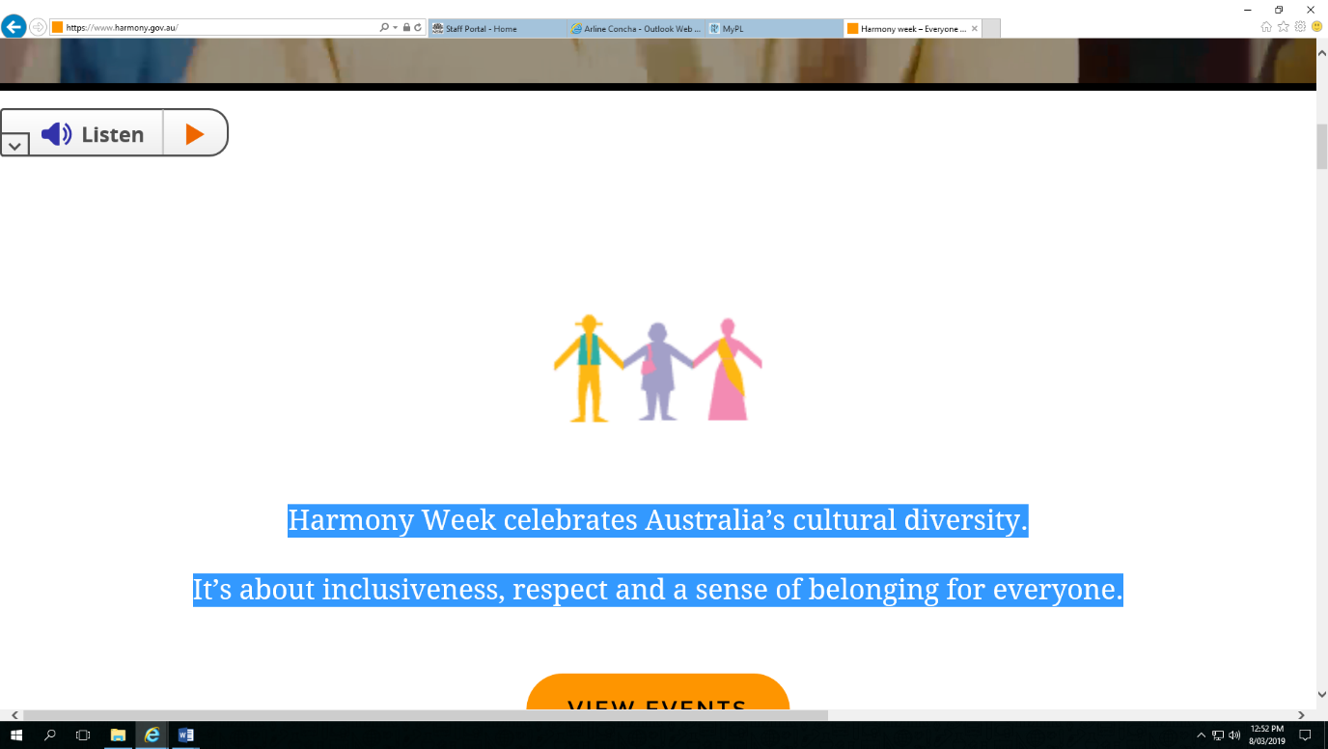

**Harmony DAY**  
**21 March 2019**

***Everyone belongs***

*Harmony Week celebrates Australia’s cultural diversity.*

*It’s about inclusiveness, respect and a sense of belonging for everyone.*

This year we will celebrate Harmony Day on **Thursday 21st March**. Students will learn about diversity and tolerance through participating in hands on cultural activities and appreciating the variety of traditions and cultures in Australia.

**Harmony Picnic**

Parents and families are also invited to the Harmony Picnic. Please come and share lunch with your children (possibly with food from your own cultural background).

*Please note: we have students with severe peanut allergies at our school.*

*Please do not include peanut items in your*

*child’s lunch or picnic lunch.*

**Where:** The Playground

**Time:** Starts at 1:00 pm

During lunch parents are invited to come to the school hall to participate in our Harmony Day activity. The P&C will be selling Zooper Doopers for $1 at lunch.

**Harmony Activity**

After lunch, parents are invited to join their child’s class and participate in a cultural activity.

The colour **ORANGE** is a symbol of Harmony Day. Students are encouraged to wear something orange on **Thursday** to celebrate harmony in our school community.

Yours sincerely,

Arline Concha, Nicole Hogan and Melissa Debrincat

Harmony Day Committee