

Zig Zag Public School

**Canteen Menu (*Monday ONLY*)**

***HOT FOOD – 1st Lunch only***

**Large Pie $3.50**

**Small Pie $2.50**

**Sausage Roll $2.50**

**Hot Dog $2.00**

**Chicken Nuggets (6) $2.00**

**Cup of Noodles $2.00**

**Chicken Schnitzel Roll $3.00**

**Corn on the Cob $1.00**

**Ham & Pineapple Pizza $3.00**

**Cheesy Garlic Bread $2.00**

***SNACKS – 2nd Lunch only***

**Chips or Plain Popcorn $1.20**

**Cup of Soup $1.00**

**Cheese Sticks $1.00**

**Fruit Juice Cups $1.00**

**Ice Blocks (no sugar) (summer only) $1.00**

**Banana, Apple, Orange $0.80**

**Warm Milo $1.00**

**Snack Cups $1.00**

**(celery, carrot, apple)**

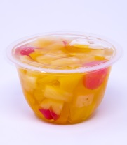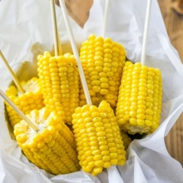

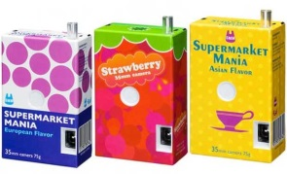

***DRINKS***

**Orange Juice $1.50**

**Apple Juice $1.50**

**Strawberry Milk $1.50**

**Chocolate Milk $1.50**

**Plain Milk $1.00**

**Water $1.50**

***SANDWICHES – 1st Lunch only***

***Plain or Toasted***

**Vegemite $1.50**

**Baked Beans $2.00**

**Spaghetti $2.00**

**Ham $2.00**

**Chicken $2.00**

**Tuna/Salmon $2.00**

**Extra fillings – cheese, lettuce $0.50**

**Tomato**

**Tin Tuna $1.50**

**Tin Salmon $2.00**

**Egg (lettuce optional) $2.50**

**Curried Egg (lettuce optional) $2.50**

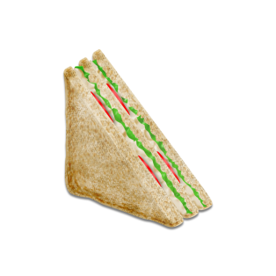

**Brown Paper Lunch Bags 10c each**

**Sticky Beaks Reusable Lunch Bags $11**

**(blue, pink, green, purple)**

**Please send the correct money with your child’s lunch order.**

**Sorry NO CREDIT is given.**