**Stage 1 News – Year 1 and Year 2**

A Focus on Maths

Each week we focus on 2 elements of Maths. 1 element is from the “number” part of maths and the other element is from “measurement and geometry” or “data and probability”.

This week our number focus is Patterns and Algebra.

|  |  |
| --- | --- |
| WALT  (We Are Learning To) | Investigate concepts of number   * Distinguishing between odd and even numbers * Learning strategies to identify if a number is odd or even |
| WILF  (What I’m Looking For) | 1. Students who can model even numbers 2. Students who can identify that even numbers count by 2s (starting from 2) 3. Students who can model odd numbers 4. Students who can identify that odd numbers also count by 2s (but starting at 1) 5. Students who can identify whether larger numbers are even or odd |

We watched YouTube explanations of how to work out if a number is odd or even

We had a variety of counters and blocks and physically represented odd and even numbers

By the end of topic, we can look at objects and just know if they all have a pair – then it’s even. And if there is one left over – it’s odd

Do you like our little ditty to help us remember?

If it’s even there’s a pair

If it’s odd there’s a spare

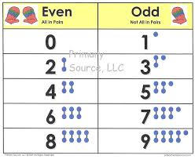

We met Odd Todd and Even Steven

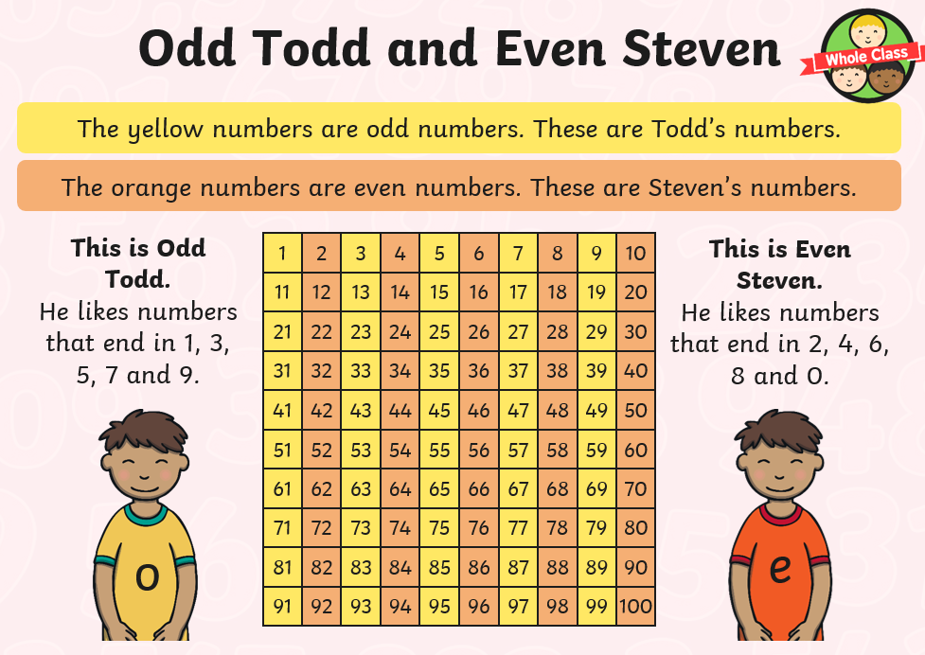

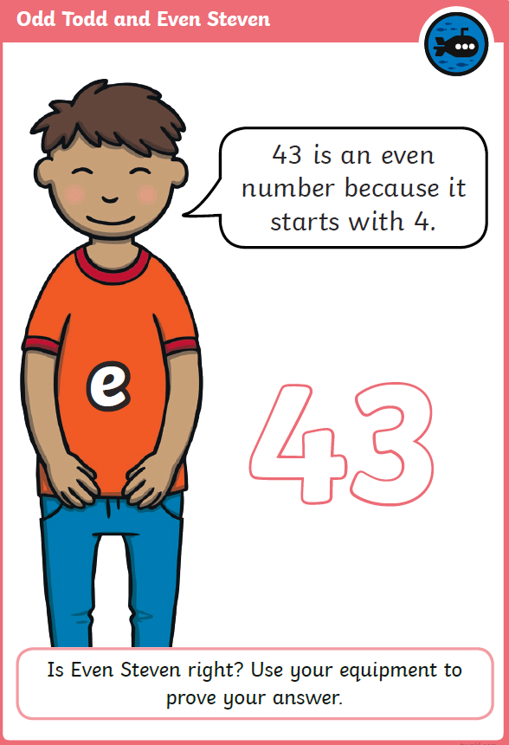

We also looked at

Even Steven’s

thinking and

proved him

WRONG!!

This week our other maths focus is capacity.

|  |  |
| --- | --- |
| WALT  (We Are Learning To) | Investigate concepts of capacity   * Determine how much a container can hold (using cups full rather than mL) |
| WILF  (What I’m Looking For) | 1. Students who can compare the capacities of two or more containers 2. Students who can estimate capacity by referring to the type of units they want to measure with and how many 3. Students who can check their estimation by measuring 4. Students who can recognise that containers of different shapes may have the same capacity |

We watched a YouTube clip that explains what capacity is and how to measure it using terms such as empty, nearly empty, half full, nearly full and full.

We did an investigation called More, Less, About the Same. We chose 2 things in the classroom where one of them would hold MORE and the other would hold LESS.

Then we took one of those objects and had to find someone else in the room that had an object that was ABOUT THE SAME.

[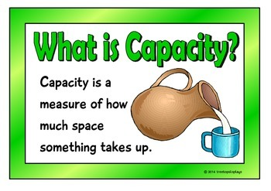](https://www.google.com/url?sa=i&url=https%3A%2F%2Fwww.teacherspayteachers.com%2FProduct%2FMeasuring-Capacity-Metric-System-1146865&psig=AOvVaw1tTmZJusmzpcNvSJJaBIgu&ust=1591162646179000&source=images&cd=vfe&ved=0CAIQjRxqFwoTCKCtvPy04ukCFQAAAAAdAAAAABAD)

Then we played a game called How Much Will It Hold?

Every class took their containers outside ready to fill with water. The teacher used a small cup and filled it up once. Then they poured it into the child’s container. The child then had to use their estimation skills to guess how many more cups full would be needed to fill their container up.

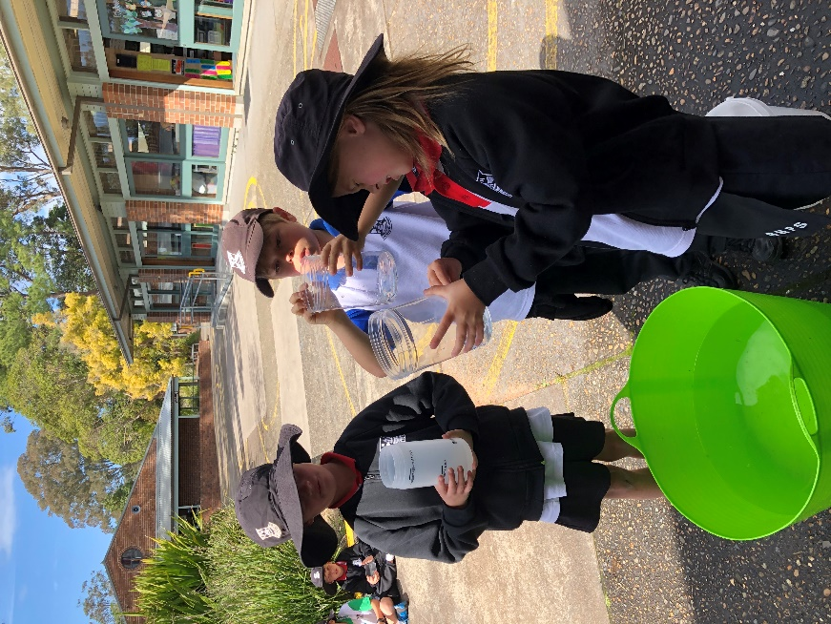

It seems that the “one-eyed squint” is the most effective way to really look at the water in the container and predict how many more are needed!

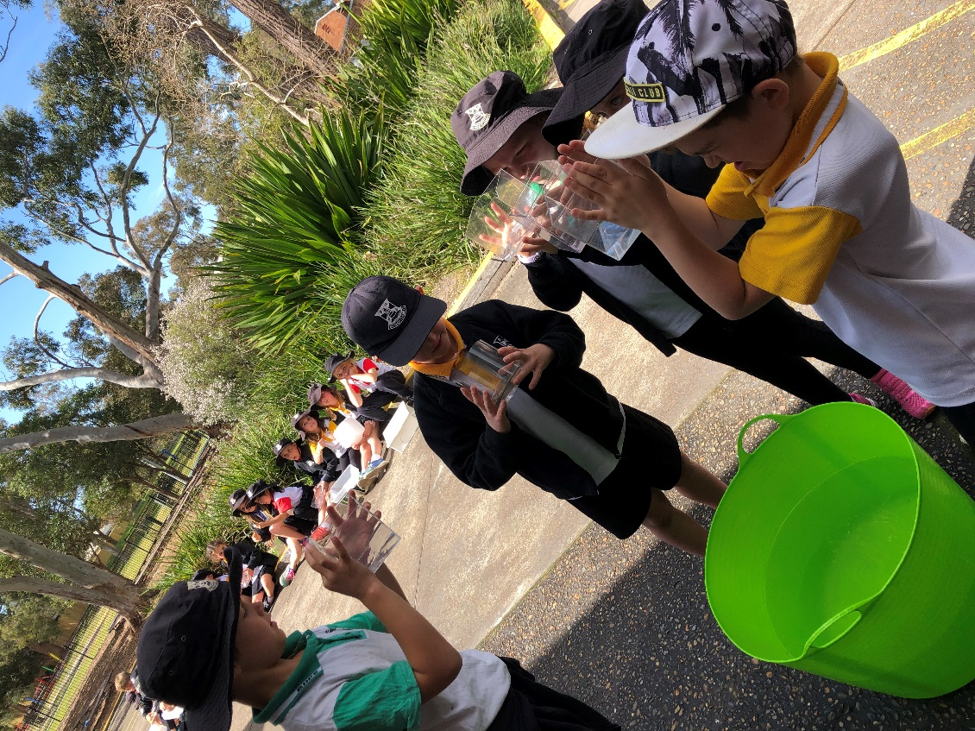

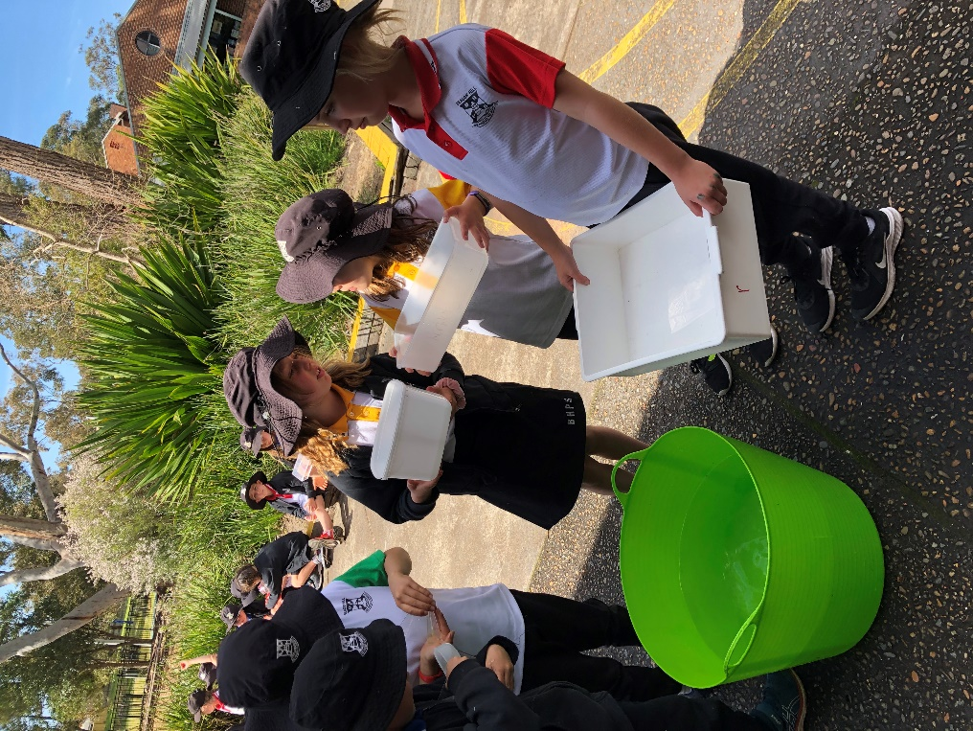

The “one-eyed squint” was not required here – But a bigger cup was!!

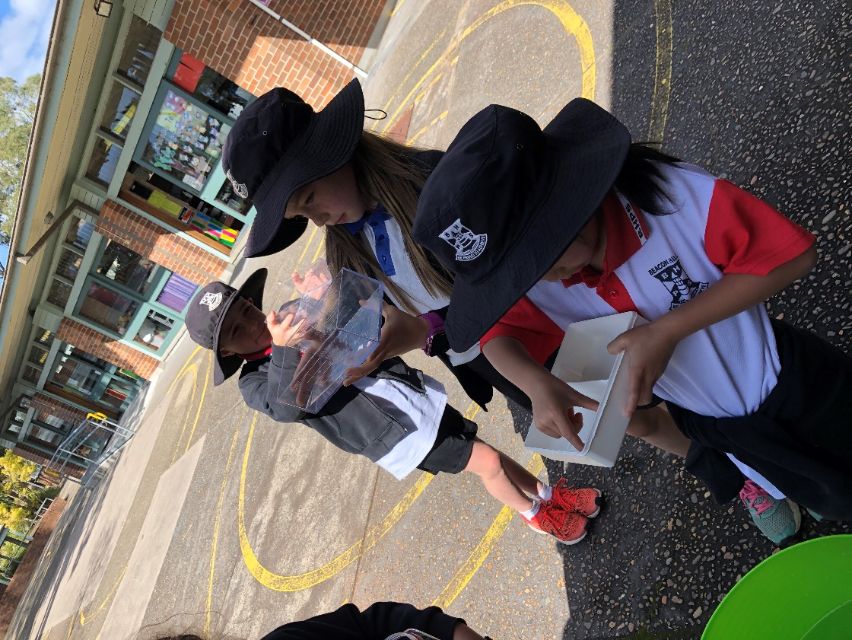

Fingers are also a great strategy to use to guess how many more are needed

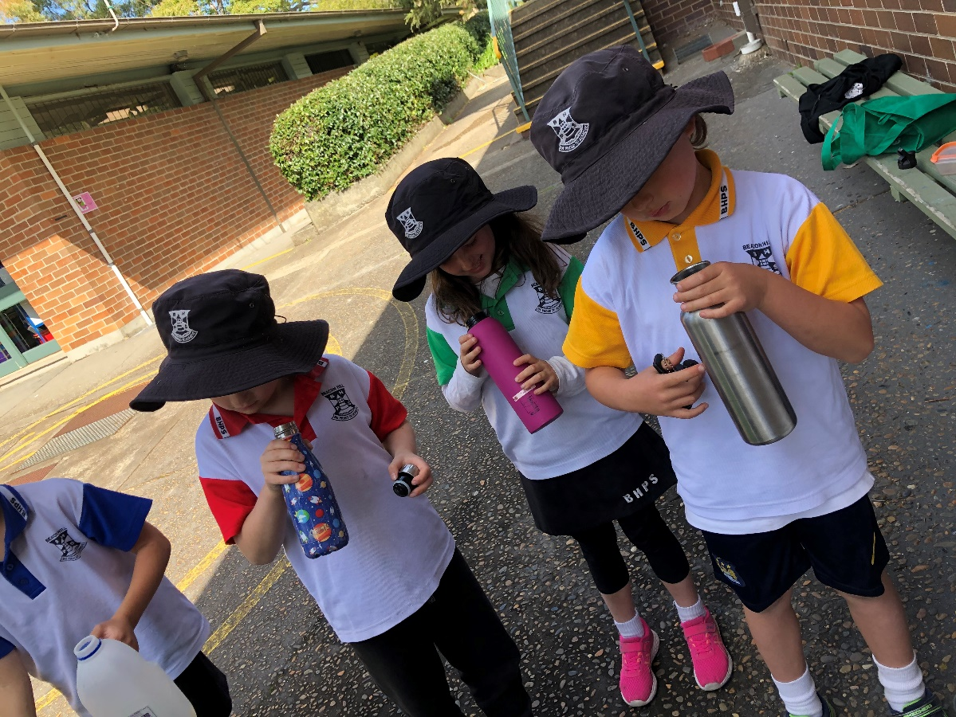

It is really tricky to guess how many are needed when it’s hard to see in the container!!

WE HAD SUCH A FUN TIME

LEARNING OUR MATHS CONCEPTS THIS WEEK!!