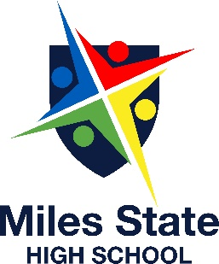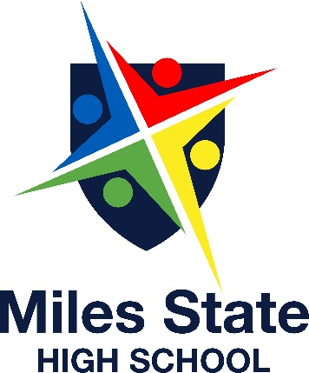

**Wedges 3.00 Assorted Toasted Sandwiches 4.00**

**Wedges with sour cream Ham/Cheese/tomato**

**& sweet chilli sauce 4.00 Chicken/cheese/gravy**

**Chicken Burger 6.00 Ham/cheese**

**Salad Wraps 5.00 Assorted Sandwiches 4.00**

**Salad Box with meat 6.00 Chicken & Gravy Sub 5.00**

**Hamburger 6.00**

**2 x Devil Wings 4.00 Sweet Chill wrap 6.00**

**Meat Pies 4.00 Zinger burger 6.00**

**Hot dog with cheese 3.50 Pizza Scrolls (4) 3.00**

**Devil Wrap 6.00 Red rock chips 1.50**

**Bacon & Egg Muffin 4.00 10 x Nuggets & sauce 5.00**

**Sausage roll 3.00 Fruit – seasonal 3.00**

MILES STATE HIGH SCHOOL

TUCKSHOP MENU

Shelley’s P & C

Tuckshop…..

What’s 4 lunch Kids ???

**Orders may be placed with tuckshop convenor Shelley:**

* **Before school for first Break**
* **At First break for Lunch**
* **Assorted hot Meals Monday – Thursday.**

**What treats Shelley’s cooking up and when?**

* **Homebake cooking Wednesday’s ONLY.**

DRINKS:

Mt Franklin Water 2.00

Pump Water 3.00

Flavoured Pump 4.00

Fruit Juice 500ml 3.50

Flavoured Milk- Lge 4.50

Flavoured Milk- sml 3.50

Plain Milk – 600ml 3.00

Fruit Bomb – assorted 2.50

Iced Tea – peach/mango 3.50

|  |  |  |  |
| --- | --- | --- | --- |
|  |  |  |  |

|  |  |  |  |
| --- | --- | --- | --- |
|  |  |  |  |

Ice Blocks:

Icy Bites 1.00

Lifesavers 2.00

Milo Cup 3.50

Billabong 2.00

Extras:

Tomato sauce 0.50

BBQ sauce 0.50

**EFTPOS AVAILABLE May 2020**