REPORTING TO PARENTS - SEMESTER ONE, 2023

This year, parent-teacher interviews are scheduled to take place on Wednesday, 5 April between 12 pm and 6 pm. These conversations are a wonderful opportunity to gain an overview of how your children are progressing and to discuss learning goals for the year ahead. Please note that school concludes at 11:30 am on this day.

Important Information

- Each interview will be 10 minutes long.
- Chimes will be sounded to signal the start and end of interview times. In fairness to teachers and other parents, it is important that all parents adhere to these times. One late interview has a domino effect throughout the school.
- If you miss your interview time, or still have concerns about your child after the interview, please arrange another mutually convenient time to meet with the relevant teacher.
- Bookings are made using an online system. Instructions are attached.
- The online booking system will open at 9 am on Friday 17 March.
- An additional interview date (Friday 24 March) is available for parents of kindergarten students. These parents may choose to attend an interview on either the 24 March or 5 April, regardless of which kindergarten group their child attends.

Picking up students at 11:30 am on the day of interviews
When booking your interview, be sure to answer the questions advising your plans for your child from 11.30am on the day of the interviews. Children who remain at school will be supervised until 3.00pm. Zigzags After-School Care and the crossing guards on local streets will operate at their normal times.

Warmest regards,

Hannah Cole
ASSOCIATE PRINCIPAL
10 March 2023

Dear Parents,

Parent/Teacher/Student interviews will be held shortly.
Interviews are strictly 10 minutes and spaces are limited. If you require more time with a particular teacher, please arrange a separate meeting by emailing the classroom teacher on March 31. Email addresses can be obtained from the school website (http://www.glengarry.wa.edu.au/ourschool.php?id=90).

Families with children in Kindergarten also have the option of making an interview time on Friday 24 March, this must be booked by Wednesday 22 March.

Wednesday 5 April:
Go to www.schoolinterviews.com.au and enter the code: w3ym8

Friday 24 March:
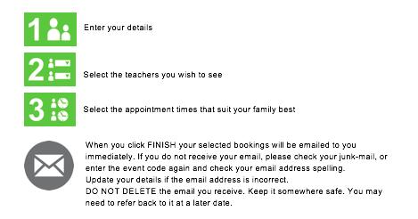
Go to www.schoolinterviews.com.au for interview times for Kindergarten Only enter the code: nx2z6

REMEMBER TO ADD YOUR APPOINTMENTS TO YOUR CALENDAR - reminders will not be sent home.

Bookings must be finalised by March 24th at 4pm.

If you need to view, cancel, change or print your bookings:
- Click on the link in the confirmation email you received after you made your bookings
- OR return to www.schoolinterviews.com.au and enter the code and the email address you used when making your bookings.

