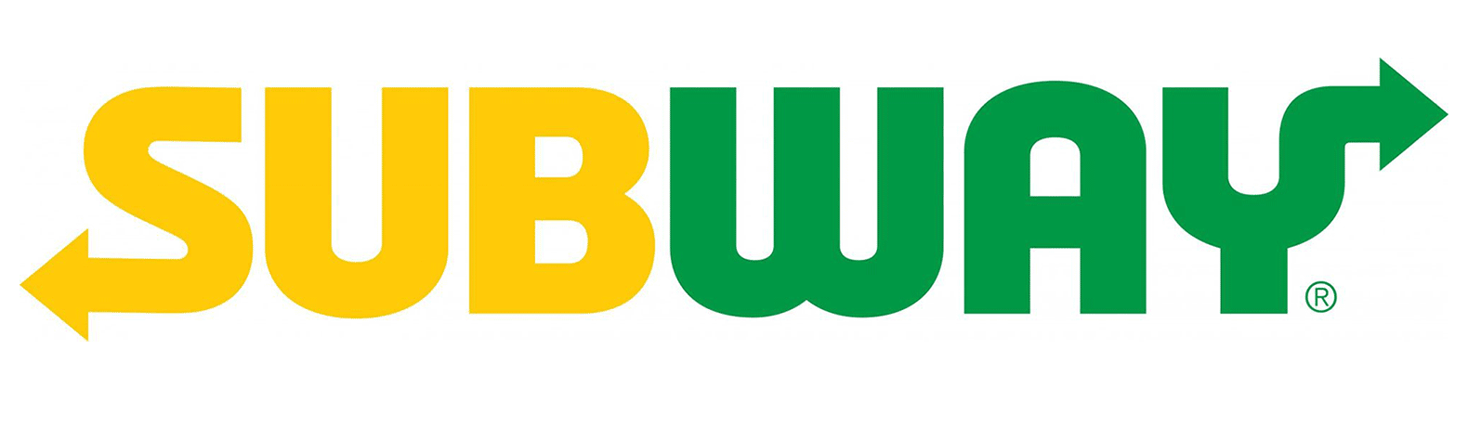
School Lunch Order
Student Name _____________________Class __________ Teacher__________________
Salad Selection
-Lettuce
-Tomato
-Cucumber
-Carrot
Cheese selection
-Cheddar cheese
-No Cheese
Meat Selection- Circle one
-Chicken
-Ham
-Roast beef
-Tuna with mayo
-Vegetarian

Sauce Selection
-Mayo
-Tomato
Drink Selection – Circle one
Water
Apple Juice
Choc Milk

Please note – all subs are made on white bread. No other options are available.
$6- please provide correct money (No change can be given.)

School Lunch Order
Student Name _____________________Class __________ Teacher__________________
Salad Selection
-Lettuce
-Tomato
-Cucumber
-Carrot
Cheese selection
-Cheddar cheese
-No Cheese
Meat Selection- Circle one
-Chicken
-Ham
-Roast beef
-Tuna with mayo
-Vegetarian

Sauce Selection
-Mayo
-Tomato
Drink Selection – Circle one
Water
Apple Juice
Choc Milk

Please note – all subs are made on white bread. No other options are available.
$6- please provide correct money (No change can be given.)

